Electricity Price Prediction Model

Feature Engineering:

Historical Data: Gather historical electricity price data, which should include timestamps and price values.

Time-Based Features: Extract relevant time-based features such as hour of the day, day of the week, month, and year.

Lagged Features: Create lagged features, like previous hour/day prices, to capture temporal patterns.

Weather Data: Integrate weather-related features if available (e.g., temperature, humidity, or weather conditions) as they can influence electricity demand.

Holidays: Consider adding binary flags for holidays as they can affect electricity consumption.

Model Training:

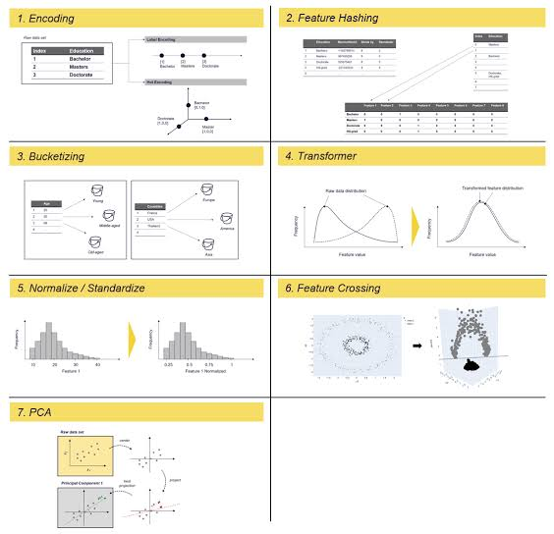

Data Splitting: Split your data into training, validation, and test sets. A common split is 70-15-15, but it can vary depending on your dataset size.

Select Model: Choose an appropriate model for time series prediction. Common choices include linear regression, decision trees, random forests, and more advanced models like ARIMA, LSTM, or Prophet.

Feature Scaling: Normalize or standardize your features if needed.

Model Training:

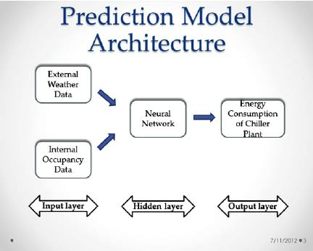

Train your chosen model on the training data using the selected features.

Hyperparameter Tuning: Optimize hyperparameters using techniques like grid search or random search.

Evaluation:



Metrics: Select appropriate evaluation metrics for regression tasks. Common metrics include Mean Absolute Error (MAE), Mean Squared Error (MSE), Root Mean Squared Error (RMSE), and R-squared (R^2).

Model Evaluation: Evaluate the model's performance on the validation set using the chosen metrics.

Fine-Tuning: Refine the model based on the validation results. You may need to adjust features, hyperparameters, or even consider trying different models.

Final Evaluation: Once satisfied with the model's performance, evaluate it on the test set to get an unbiased estimate of its predictive power.